Warning – MyKey Park Aid – CGEA 1.3

Functional Description

The purpose of the MyKey Park Aid Warning feature is to inform the driver that Park Aid cannot be deactivated when a MyKey is in the ignition. This feature supports vehicles equipped with Park Aid switch, which is typically FoE variants.

The MyKey Park Aid Warning feature correlates the PrkAidSwtch_B_Stat, the configuration information, and the operational mode to display the appropriate warning display in the message center.

Interfaces

Interface Context Diagram (I/O Block Diagram)
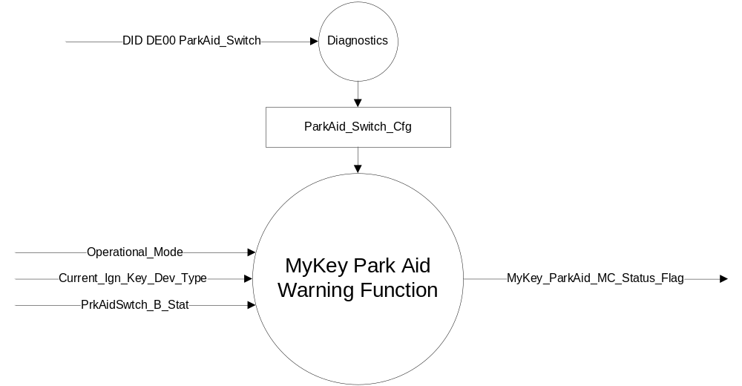
Figure 1 Warning – MyKey Park Aid Warning Function Context Diagram

Inputs
      - INTERNAL:
            - Operational_Mode
            - Current_Ign_Key_Dev_Type (see MyKey Gen II Control Function STSS)

- MUX message from the CAN bus

- PrkAidSwtch_B_Stat Signal
Signal Name | Size (bits) | Detail | Units | Res. | Offset | State  Encoded | Min | Max
PrkAidSwtch_B_Stat | 1 |  | SED | 1 | 0 |  | 0 (0x0) | 1 (0x1)
 |  | Not_Pressed |  |  |  | 0x0
 |  | Pressed |  |  |  | 0x1

Outputs
- MyKey_ParkAid_MC_Status_Flag that is used to control the Warning displayed in the message center.

Function/Performance

Operational Modes

Mode | Differentiating Vehicle Conditions
Sleep Mode | OFF
Limited Mode | OFF
Normal Mode | MyKey Park Aid Warning Messages OFF/ON
Crank Mode | MyKey Park Aid Warning Messages OFF/ON

Voltage Levels

Refer to the Cluster Features Table located in the Operational Modes and Voltage Range Strategies Section of this SPSS.

Human-Machine Interface

Visual

Indicator Graphics / Display Format
Message Center Text Warning Message as defined in section 1.3.5.1 of this document.

1.3.3.1.2 Indicator Color Coordinates

Reference section COLOR & ILLUMINATION REQUIREMENTS (GRAPHICS)

1.3.3.1.3 Indicator Characteristics

For High End Display (SHMI), reference HMI Specifications:
Text: Program Master Warning Message List.xls | Program Translation Table.xls

Reference the following Message IDs in the Text Message List file for the appropriate display: W892.

Audio

None.

Switch Control Logic

None.

System Accuracy

- The state of the message center flags shall change within 100 msec of a state change as indicated in the state matrix found in section 1.3.5.1 of this document

Operation: Performance and Functional

Subsystem Algorithm Flowchart / State Diagram

- StartSystem_MC_Status_Flags
Operational  Mode | ParkAid_  Switch_Cfg | Current_Ign_Key_Dev_Type | PrkAidSwtch_B_Stat | MyKey_ParkAid_  MC_Status_Flag
Normal or  Crank | Enabled | 0x2  (Key_In_Ign_My_Key) | 0x1  (Pressed) | Active
All other Cases |  |  |  | Inactive

- StartSystem_MC_Status_Flags to MC Warning Message ID
MyKey_ParkAid_  MC_Status_Flag | MC Warning  Message ID
Active | W892
Inactive | None

Operation Description (supports algorithm flowchart /state diagram)

- When MyKey_ParkAid_MC_Status_Flag = Active, Warning ID W892 will be Active.

Function Safety Classification (EMC)

Class B

Memory Storage

Parameter Name | Description | Value at  Battery Connect | Value at  Module  Wake-up
MyKey_ParkAid_MC_Status_Flag | Used to control the state of the warning to the Message Center arbitrator | Inactive (0X0) | Inactive (0X0)
Operational_Mode | 4 state indicator for cluster operational mode | Limited | Limited or Normal or Crank
Current_Ign_Key_Dev_Type | Used to indicate the type of key currently in use in the vehicle. This parameter is identical in encoding to the IgnKeyType_D_Actl signal on HSCAN. | Unknown (0x0E) | Unknown (0x0E)
PrkAidSwtch_B_Stat | CAN signal | 0x0 | 0x0

Prove Out

No.

Reconfigurable Telltale

No.

Message Center Msg

Refer to Text: Program Master Warning Message List.xls | Program Translation Table.xls warning W892.

Error Handling

Missing Message/Undefined Data Strategy

None

Invalid Message Strategy

None.

Diagnostics

Self Test

None

Engineering Test Mode

Reference section “Dealer / Engineering Test Mode (ETM)”

Part II Performance

Supported Diagnostic DIDs (Service $22 and $2F)

Supported Diagnostic Trouble Codes (DTCs)
DTC | Description | When Logged

DID DE00 Configuration
Block  Num | Block Description | Byte(s) | Bits | State: Description | "0" | "1" | Default | Comments/Information
PACKETED BLOCKS
$00 | Option Content (B&A) | * | * | ParkAid_Switch | Disabled | Enabled | Disabled
 | *Byte and bit location to be identified in Part II Specification for this cluster

Reference Specification

IS-0001 WARNINGS/INDICATORS/DISPLAYS PROVEOUT
IS-0052 OPERATING VOLTAGES - FUNCTIONAL/PERFORMANCE
IS-0069 FUNCTIONAL IMPORTANCE CLASS
IS-0324 WINDSHIELD & OTHER REFLECTIONS
IS-0327 WARNING INDICATOR EVALUATION
IS-0379 NORTH AMERICAN WARNINGS AND INDICATORS STRATEGY

IL-0017 TELLTALE AND INTERIOR ILLUMINATION – COLOR AND INTENSITY
IL-0019 GENERAL ILLUMINATION DIMMING
IL-0021 CRAFTSMANSHIP – DISPLAYS
IL-0022 GENERAL ILLUMINTATION COLOR
IL-0023 CLARITY/LEGIBILITY/READABILITY/VISUAL CONTRAST
IL -0043 OPERATIONAL ENVIRONMENT FUNCTIONALITY
IL -0045 COLOR
IL -0047 TELLTALE, INDICATOR AND DISPLAY LIGHT INTENSITY
IL -0048 ILLUMINATION ACCEPTABILITY

03-0661 PLACEMENT: CONTROL AND DISPLAY LOCATIONS
03-0662 PLACEMENT: LOGICAL GROUPING FUNCTION AND USAGE
03-0664 PLACEMENT: DOWN VISION TO COMPONENTS WITH HIGH VISUAL DEMAND
03-0665 PLACEMENT: EXPECTED LOCATIONS OF CONTROLS AND DISPLAYS VDS
03-0670 INTERIOR VISIBILITY
03-0671 INTERIOR VISIBILITY: REFLECTIONS FROM COMPONENTS & SURFACES
03-0672 INTERIOR VISIBILITY: REFLECTIONS IN DISPLAYS
03-0673 INTERIOR VISIBILITY: VISUAL OBSCURATIONS
03-0674 INTERIOR VISIBILITY: ILLUMINATION CONTROLS / DISPLAYS
03-0675 INTERIOR VISIBILITY: VEILING GLARE
03-0677 INTERIOR VISIBILITY: SUNLIGHT WASHOUT
03-0681 IDENTIFICATION: CHARACTER AND SYMBOL SIZE
03-0682 IDENTIFICATION: LEGIBILITY
03-0685 IDENTIFICATION: SYMBOLS, ABBREV FOR CONTROL
03-0721 LOGIC OF OPERATION: OPERATIONAL STEREOTYPES
03-0722 LOGIC OF OPERATION: INTERPRETATION
03-0723 LOGIC OF OPERATION: USE OF SYSTEMS WITH VISUAL DISPLAYS

Revision History

SPSS Module Revision History

Revision Level | Name | Change Description | Date
1.0 | J. Gregoire | Initial Release. | 7/1/2011

